[[

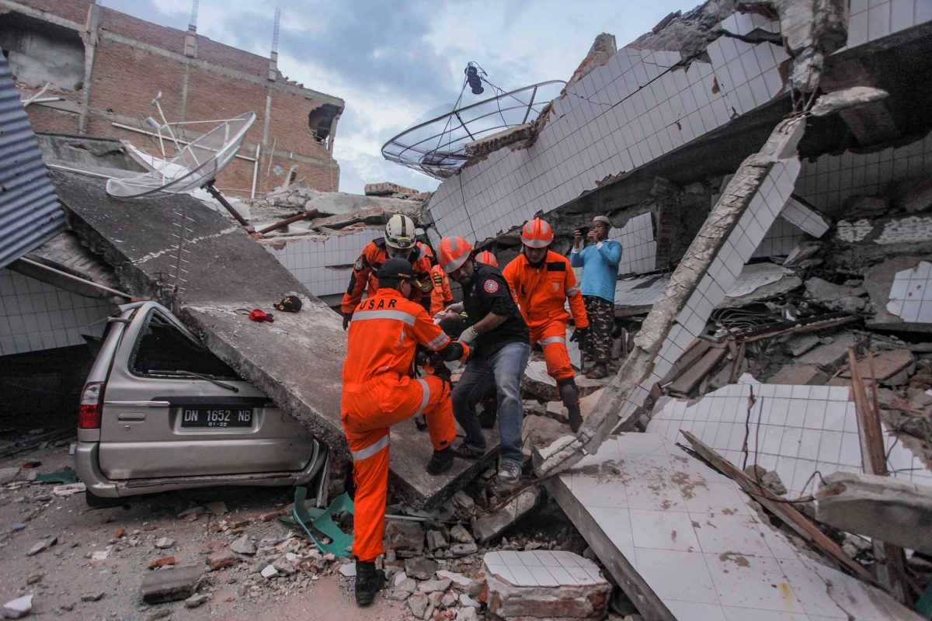

Contingency planning guide


Photograph showing Earthquake in Los Angeles in California
EARTHQUAKE AT THE EPICENTER OF THE METROPOLITAN AREA OF LOS ANGELE.
DISASTER PLANNING GUIDE
SPECIFIC OBJECTIVES
BY THE END OF THIS ANALYSIS THE READER SHOULD BE ABLE TO:
1. Understand why we must plan for emergencies and disasters.
2. Define what an effective emergency plan should include.
3. Define the role of the plan administrator.
4. Recognize the hazards facing a healthcare facility.
5. Prepare a Vulnerability Analysis.
6. Understand the planning process.
7. List the emergency management elements of a plan.
8. Define the primary steps in developing an emergency/disaster plan.
9. Identify issues and concerns that should be addressed when developing a plan.
10. Form a planning team.
11. Understand what Contingency Planning is.
12. Prepare a Contingency Impact Analysis.
13. Define critical business functions.

EARTHQUAKE AT THE EPICENTER OF THE METROPOLITAN AREA OF LOS ANGELES
TABLE OF CONT
Preface……...…………………………………………………………………………………..8
Introduction....................................................................................................................................8
Chapter1. Prepare………………………………….…………………………………………….8
1. What is contingency planning?....................................................................................................9
2. When and how to plan…………………………………………………………………………9
3. National Society mandate and contingency planning…………………………………………11
4. Humanitarian reform and the cluster system………………………………………………….11
5. Principles, quality and accountability…………………………………………………………12
6. Data collection and practical steps to prepare for planning…………………………………...13
Chapter2. Analyze………………………………………………………………………………14
1. Introduction……………………………………………………………………………………14
2. Hazards………………………………………………………………………………………..17
3. Vulnerability and capacity assessment (VCA)………………………………………………17
4. Risk analysis…………………………………………………………………………………..20
5. Disaster impacts……………………………………………………………………………….21
6. Role, mandate and capacity of the National Society………………………………………….21
7. Developing scenarios………………………………………………………………………….22
Chapter3. Develop ……………………………………………………………………………26
Introduction……………………………………………………………………………………26
2. Strategy, goal and objectives…………………………………………………………………27
3. Activation of the plan………………………………………………………………………….29
4. Management…………………………………………………………………………………..29
5. Coordination…………………………………………………………………………………..33
6. Quality and accountability…………………………………………………………………….34
Chapter4. Implement…………………………………………………………………………...36
1. Introduction……………………………………………………………………………………36
2. Preparedness gap analysis and action plans…………………………………………………...37
3. Standard operating procedures (SOP)…………………………………………………………41
4. Early warning, alert systems and triggers……………………………………………………..44
5. Human resources………………………………………………………………………………44
6. Resource mobilization………………………………………………………………………...46
7. Training and simulation……………………………………………………………………….47
8. Linkages and communications………………………………………………………………...48
Chapter5. Review……………………………………………………………………………….49
1. Updating and evaluating the plan……………………………………………………………..49
2. Evaluating during (real-time) and after the response………………………………………….51
Annex 1. Contingency plan format……………………………………………………………52
Annex 2. Sector responsibilities………………………………………………………………..54
Annex 3. Identifying capacities and resources………………………………………………..66
Annex 4. Standard operating procedures (SOP)……………………………………………..69

PREFACE
The information in thiscontingency planning guide will be able to address the issues to be tackled by the disaster management team and how to mitigate them when such an incident occurs. This information has been compiled by considering the specific threat of earthquake at the epicenter of the metropolitan area of Los Angeles, California (local/ community level) where exactly that threat and impact occurred. This planning guideline also addresses the requirements as set forth in the Disaster Management Team (DMT) of California Hospital Medical Center (CHMC) (Dignity Health).

CHAPTER 1: PREPARE
INTRODUCTION
The records of earthquakes in California exist that affected the Spanish missions that were constructed beginning in the late 18th century. Since then another occurrence of the earthquake in California it usually came from the ship captains and other explorers. In 1769, was documented as the earliest known earthquake to occur by the Spanish and the Catholic missionaries of the Portola expedition as they travel the present site of Los Angeles. Around 1850-2004, there has been about one potential damage event per year on average with no damage recorded.
Later few damaging earthquakes that occurred in the American Midwest and the East Coast were well known which became apparent to the settlers that the earthquake hazard situation was much different in the West. In 1868 Hayward event affected the thriving financial hub that is the San Francisco Bay Area, with damage from Santa Rosa in the north to Santa Cruz in the south. This led to the destruction of many properties until the scientist and the healthcare organization became aware of the destruction.
In 1906 San Francisco earthquake moved the USA into acknowledging the problem that was caused by the earthquake. The Long Beach earthquake in 1933 occurred in a populated area where it destroyed a large number of public properties in Los Angeles and in Long Beach. Later, the San Fernando earthquake affected the San Fernando Valley north of Los Angeles with heavy damage to several hospitals which even led to the loss of life of many people. Therefore, the central goal of this article is to understand from the experience that happened in Los Angeles and set the strategies or plan on how to deal with such incidents in the future.
- What is contingency planning?
Contingency planning is a planning scheme for preparing the government or an organization on how to deal well on the emergences or to prevent those emergencies in the future. Developing an effective contingency planning involves earlier preparation on how to deal with the emergences and organizing the resources to deal with such problems in advance. The contingency planning helps the planner to think more systematic on how to deal with the specific threat as they occur. Therefore,contingency plan aims to prepare an organization to respond well to an emergency and its potential humanitarian impact and formulatecertain procedures on how to deal with such threat in future.
- When and how to plan?
The contingency planning aims at preparing the organization to respond well to an emergency and its potential humanitarian impacts, this is because no one can easily predict how future events over an organization control will affect its operation in future. To overcome this it’s so effective for an organization to prepare in advance on how to deal with such events as they occur. As Senior Director of the Disaster Management Team (DMT) of California Hospital Medical Center (CHMC) (Dignity Health), they have to come up with a plan to help them to identify unknown scenarios that may affect their operations, such as earthquakes and how they will respond to that scenario.Also, this plan has to be updated regularly to fit with the changing situation.
Contingency planning has to embark when there are high chances for the occurrence of an emergency situation or when there is a probability for the occurrence of a certain disaster, also it can be applied in a situation where there is an evidence for the occurrence of a disaster.
During planning it is also important to answer some of the critical questions that would help you during planning like what do you want to plan for? Who have to plan? When to plan? Like in this plan, it is designed to assist in the preparation of the contingency plans considering the specific threat of earthquake at the epicenter of the metropolitan area of Los Angeles, California (local/ community level). This planning has to look at a number of several factors that are responsible for the planning processes.
The one responsible for planning should be someone from the Disaster Management Team or the support from the organization concern.In this case of the earthquake in California, the key resource person is the Senior Director of the Disaster Management Team (DMT) of California Hospital Medical Center (CHMC) (Dignity Health). Teamwork was also embraced during this planning for the good production of the plan.
When planning a contingency plan it is necessary to plan it under national or regional level, this is because for the wider coordination and response to large-scale disasters outreach.However, some of the plans can be done for the individual country while others can be done to reach the whole world.
- National Society mandate and contingency planning
Disaster Planning for California Hospitalconference formulated to bring together the largest audience of hospital staff, emergency responders, and state and local health officials to discuss the major issue of disaster management in California. Together with the Disaster Management Team (DMT) of California Hospital Medical Center (CHMC) (Dignity Health) are the one attributed or mandated for the contingency planning in California. However, the expert panelists from Kaiser Permanente, Sutter Health, the California Department of Public Health and the Office of Statewide Health Planning and Development are also major bodies that are concerned to deal with the disaster in California.
Apart from the above bodies, National Societies have to be developed toa precise role in times of disaster, negotiate and define with its government on how to deal with the disasters. Policies should be developed accordingly, and the society’s role incorporated into the government’s national disaster plan for effective dealing with disaster especially the earthquake.
- Humanitarian reform and the cluster system
In the case of occurrence of any emergencies, it will need for good coordination which will lead to fewer gaps in the assistance delivered by humanitarian organizations. Since 2005a major reform of humanitarian coordination introduced a number of new elements to enhance partnership and cluster system being one of them. Cluster systems or approaches are groups of humanitarian organizations such as the United Nation in every main sector of humanitarian action. In California, cluster system has to be taken in place to deal with the outbreak of the earthquake with the collaboration of Disaster Management Team (DMT) of California Hospital Medical Center (CHMC) (Dignity Health).
The IFRC has a responsibility to convoke the global shelter cluster over the natural disaster. During the contingency planning should effectively consider this global obligation and make specific preparation for it on how to deal with the natural disasters. In the case where an emergency response is of an international scale then it will call for all national societies that are a concern with the disaster management during the preparation of the contingency planning. Sometimes Humanitarian Country Team can call upon the National Societies to carry out the process of planning on behalf of the IFRC. When such then the National Societies would ask for the support from the IFRC or sometimes can use the Inter-Agency Contingency Planning Guidelines and the Shelter Cluster Contingency Planning Checklist for preparation.
- Principles, quality,and accountability
During contingency planning, there must be heedful given to the principles, standards, quality,and accountability that can govern the movement during the contingency plan. Principles have to be put in place to assist insurers in developing prudent approaches to managing earthquake disaster specifically in California. Some of these principles may include Earthquake Exposure Risk Management, earthquake exposure data, earthquake models and financial resources and contingency plans all this can assist during the outbreak of the earthquake in California. However, the constitution of the IFRC, national legislation,and Disaster Management Team (DMT) of California Hospital Medical Center (CHMC) (Dignity Health) can formulate policy on how to deal with the emergencies outbreak such as the earthquake.
- Data collection and practical steps to prepare for contingency planning
Preparedness for planning involvethe activities and measures taken in advance to ensure effective response to the destructive impacts of disasters in the future. This preparation is seen as the best procedure to reduce earthquake occurrence in California or elsewhere. During preparedness strategies like data collection can be used at either individual or community level in advance by collecting survival items and mitigation activities.
Through data collection, questionnaire development can be used to collect data for the preparedness of contingency plan which can be grouped into three categories; literature review and focus group discussions, measurement of the tool validity and the measurement of the instrument reliability. Under the following analysis, it highlights major concepts on which contingency planning should work upon during Data collection and practical steps to prepare for planning earlier.

CHAPTER TWO: ANALYSIS
Contingency planning process of California Hospital
- Introduction
Contingency planning process of California hospital should include three components. First, it should give an estimate of what is going to happen, a plan on how the response should be and some actions identified to be best prepared. This chapter helps the planners to predict what is going to happen and the impacts that the earthquake will have on both the people’s lives and livelihoods.
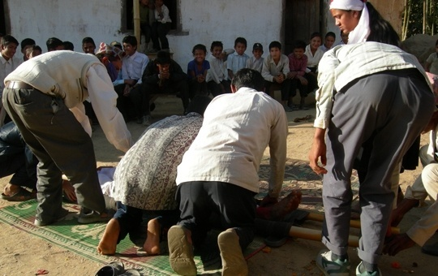

Since an earthquake is unpredictable, there is no such thing as “earthquake season” and therefore the California Hospital should always be prepared. Earthquakes can occur at any place anytime and there is no scientific method of predicting the occurrence of earthquakes. The California hospital can take the following actions in order to mitigate the risks should an earthquake happen: first the hospital should ensure that it makes the necessary repairs to the building in order to make it stronger and more tolerant to an earthquake. Also, the staff and patients should know the location of emergency exits, fire alarms, and fire extinguishers. The hospital should also check on possible cracks in the building.
The hospital should also minimize or eliminate heavy furniture, heavy glass, chandeliers, breakable items and loose objects which may fall or break easily in case of the occurrence of an earthquake. Also, the hospital should not store heavy and bulky medicine, books, and equipment on top of each other to avoid falling of such materials should an earthquake occur. The staff should also be informed of safe places in the hospital. The hospital should also consider constructing a structure with light materials such as wood instead of the common building blocks. In the case of an earthquake, the light wooden building is likely to cause less damage compared to the heavy concrete building. The wooden or steel reinforced building is not very rigid and therefore can be swayed or shaken without breaking or collapsing, unlike the concrete buildings.
In addition, the hospital should have helicopters and choppers which can be used to rescue people in case the earthquake destroys other means of transport such as roads. Again, the hospital should have tents and other temporary light structures which would ensure the continuity of operations in case the main hospital building is destroyed by an earthquake (tents cannot be destroyed because they are light).
If an earthquake strikes the California hospital, it is likely to cause deaths of many people. Many earthquakes that have occurred in the past are known for causing many deaths of people. The deaths are caused by collapsing of structures such as buildings. If an earthquake will occur in California hospital, it will cause deaths of the patients and doctors in the hospital. The collapsing of the hospitals will kill the people inside the building.
The earthquake will also lead to loss of property. It will lead to the collapsing of the hospital building which will lead to losses. The actual movement of the ground during an earthquake rarely directly causes death but most casualties result from collapsing of buildings, falling of objects and debris.

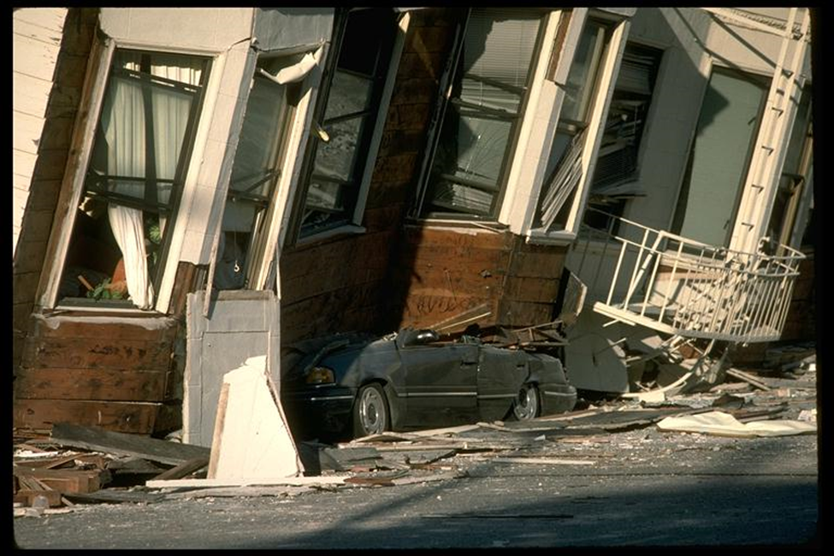 Photograph showing the damage caused by earthquakes
2. Hazards
Contingency planning is always prompted or triggered by a certain hazard. In this case, the hospital is likely to be affected by an earthquake. Earthquakes vary in their magnitude and intensity. The data on a certain hazard is very crucial because it helps in the planning process. The intensity of an earthquake measures the strength of shaking which is produced by an earthquake in a certain location. It determines the effect an earthquake has on people, structures, and the natural environment. Magnitude, on the other hand, refers to the energy released by an earthquake at the source. One characteristic of an earthquake is that it is not predictable, that is, it is not seasonal. It can occur anytime anywhere.

3. Vulnerability and capacity assessment (VCA)
This is an integral part of disaster (earthquake) preparedness that the California hospital. Vulnerability and Capacity Assessment will contribute to the creation of community-based disaster preparedness programs at the hospital. The hospital is at the risk of an earthquake occurring in the place. The use of secondary data collection to determine the extent to which an earthquake would cause damage to the social, economic and psychological well-being of the people would be very helpful. For example economic surveys, census data, research, official reports and reports from other agencies. This report would be very important in assessing the extent of damage that the earthquake is bound to bring.
Contextual information on population characteristics, stress, morbidity and mortality of the previous earthquakes in the California area would help the extent of damage that an earthquake can cause on the hospital. Maps and other forms of geospatial data would help to identify the possible physical and environmental features which would be damaged. The following shows a good VCA that can be used by the hospital.

Hazard | Potential risk | Vulnerabilities | Capacities
Earthquake | - Hospital building collapses  - Hospital equipment is destroyed  - Most vulnerable people are staff and patients | - Poor construction of the hospital  - Lack of awareness by the staff | - Proper construction of the hospital  - Training of the staff  - Evacuation plan

Physical and institutional vulnerabilities

Area of Analysis (California) | Indicators
Physical vulnerability | Presence of public infrastructure  Presence of quick evacuation means and routes  Quality of hospital construction
Organizational vulnerability | The existence of awareness of early warning systems of the earthquake  The existence of skilled response systems and plans
Institutional vulnerability | Presence of assistance entities such as the red cross  Human resources dedicated to disaster response  Financial resources in the hospital for earthquake response

4. Risk Analysis
The equation for risk analysis is Risk = hazard x vulnerability. Risk analysis is important to show the amount of time in which an earthquake takes to occur and its magnitude and intensity if it occurs. The concept of risk helps to work on how to plan for a disaster. For example, an earthquake may be of low probability but of high impact.

IMPACT
Catastrophic

Major

Medium

Moderate Likely Certain PROBABILITY

An earthquake can occur frequently but have mild effects but can take many years but when they occur, they cause a lot of damage.

5. Disaster Impacts
Having established the risk analysis it is very possible to determine the impacts of the earthquake if it should happen. The resilience of the population has been established. Also, the impact of the earthquake on the population in California and the hospital in particular. For example, how many people will be affected, what their needs will be and what immediate measures will be taken? After analyzing the earthquake hazard in California, it is possible to determine social and physical vulnerabilities. Possible impacts of the earthquake disaster in California include the death of people, destruction of property such as roads and buildings, tsunamis and landslides. In order to know the potential response to be taken are the number of people likely to be killed by the earthquake, the number of people likely to be affected by the disaster, the logistics to be taken, and the morbidity data.
6. Mandate, Role and Capacityof the National Society
The gathered information on hazards and vulnerabilities will be very helpful to plan on the resources required to tackle the impending disaster. The information thus has to be very accurate because it is this information that is used to identify weaknesses and gaps and to make use of the resources in the best way possible. After the potential needs have been identified, it will become clear how well to allocate the available resources and the additional ones that might be required.
Since responding to an emergency requires resources, the contingency plan must account for the different levels of preparedness. In order to be fully prepared for an impending earthquake, the hospital management should ask the following basic question: what resources are available to tackle the disaster and for how long it can sustain the disaster. How the community resources can be strengthened to fully prepare for the earthquake. Which staff can be brought in place during an emergency, the number of resources will be needed and what resources are currently available. The plans that exist for procuring the required resources. The steps for analyzing hazards, vulnerabilities and risks include. It starts by reviewing secondary data from scientific research and other surveys. This can help to determine the intensity and magnitude of the earthquake to be anticipated. Secondly, ensure that the hospital has the technical capacity and adequate experience for carrying out the risk analysis required for disaster response. IFRC can provide support for this.
The next step is to carry out an analysis of hazards. This information can be gathered from past emergencies, duration, frequency, magnitude and the potential impact the earthquake is likely to cause. Analyze the vulnerability level of the people exposed to the potential hazard. The five components of vulnerability which are a livelihood, well-being, self-protection, social protection, and government protection. Finally, carry out a risk analysis by combining hazards and vulnerabilities.
7. Developing Scenarios
Developing a scenario involves creating a mental picture of how a potential disaster might look like. A good scenario is very helpful because it will make the hospital to be best prepared for the imminent earthquake or any other disaster. There are three elements that define a scenario are a hazard, vulnerability, and capacity and resource. It is very important to create an image or an imagination of how things will be if the disaster strikes. The most important elements of developing a scenario are the number of people likely to be affected, priority humanitarian needs, demographics and vulnerability, geography, access, and logistical considerations, the scale of response by the community, government and aid agencies, functioning of markets, social-political dimensions and resources. The imagination should range from the least possible impacts to the worst possible impacts of the earthquake.
An example of an earthquake scenario is shown below:
Scenario | Earthquake
Best | Earthquakes measuring 4.5 on the Richter scale which causes minor damage in the hospital
Middle | Earthquakes measuring 6.5 on the Richter scale causing some major damage in the hospital.
Worst | Earthquakes measuring more than 8.0 on the Richter Scale causing catastrophic damage to the hospital and its environs.

It is also very important to imagine the level of organization that can respond to the respective scenario ranging from best to worst. For example, it is very difficult for an earthquake in the “Worst” category to be handled at the national level. Such a scenario requires international intervention. Similarly, a scenario of the “best” category can be comfortably handled by the national government or other local bodies.

Photograph showing a cracked wall due to an earthquake.

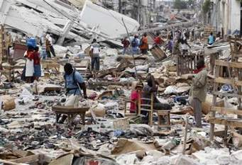
Damage caused by earthquakes

CHAPTER 3
1. Introduction
Contingency planning has three components which include an estimate of what is going to happen, a plan based on this estimate looking at what the response should be and a series of actions to help to be prepared.
This chapter looks at the second part of the formula-what the office of emergency services is going to do in response to the Earthquake disaster in Los Angeles. At the simplest level, this set out who is g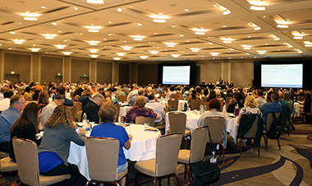oing to do what, when and where and what they will need to enable them to curb the situation that has arisen in the city.

The aim of this chapter is to help the planners to predict what is going to happen and the impacts that the earthquake will have on both the people’s lives and livelihoods. Therefore they have to come up with strategic measures of relief in case an earthquake arises. Moreover, there will be emergency preparedness between the hospital and Emergency units.
2. Strategy, goal, and Objectives
As with any project, the starting point is deciding what you what to achieve. Consequently, the starting point is deciding what you what to achieve. What are the needs to be addressed, and what can the office of emergency disaster services address the needs and response evolves. What will the emergency service department do in the week of the disaster, in the relief phase and beyond that into recovery? How much external capacity and resource will the national emergency department for combating disasters call from partners globally, for instance, emergency medical services?
Consequently, if a large earthquake strikes during rush hour southern California around the Los Angeles metropolitan area it would kill at least 3000 to 15000 people. Moreover, 12000 to 50,000 will be hospitalized.
Standard programme and project planning often tend to divide these questions into a hierarchy or ranking order, starting with the broad strategy and goals, Moreover, this is usually based on the logical framework and has more recently developed into results-based management.
In most cases, the national government has an overall responsibility for disaster response. Consequently, is important to define what Emergency Services for earthquake role be in particular how it will participate and then coordinate within the sector, especially with the other emergency units like California National Guard, Emergency Management Agency.
For the purposes of contingency planning, some of the most important decisions and theories will be based on the scale of the response and the areas of Intervention technically, geographically and over time. The key to these decisions and assumptions will be the scale of the predicted response, as this will dictate the standing capacity required, for instance, what is necessary to achieve a long-term solution. Specifically, even if it is not possible to maintain this capacity, it will almost certainly affect the initial focus of the real response.
Sector responsibilities
In addition to thinking about the scale of the response, and the broad types of intervention over time, it is useful to consider in some detail the technical areas of response. Consequently, Sector roles will vary from one National Emergency unit to another to another while it is vital to ensure that all of these sectors are specifically addressed in the planning process, actual service delivery such as external partners will ultimately need to respond to individual and community needs in a holistic manner, drawing on the different sectors to provide relevant, appropriate and effective assistance. Consequently, the primary focus should be placed on strengthening community capacities for relief and recovery and establishing good cooperation among assisting agencies to ensure that the disaster that has struck the city has been monitored and deliberate measures are taken to prevent massive damage in future.
Disaster-management continuum
It is important that the entities involved in disaster management, for instance, response preparedness for response, mitigation, and risk reduction among others are seen as being connected in contingency planning. Moreover, as relief activities decrease, recovery and risk-reduction activities will increase. Equally important, all of these elements of disaster management must support each other and one can be successfully implemented on their own.
3. Activation of the plan
Consequently, almost as essential as knowing what you are going to do in a response is to know when you are going to do it. Moreover, this small but important detail is crucial and can save hours or even days. Equally important, every plan should have a small section outlining how the plan is to be activated, when and by whom. In this case, whereby an earthquake threat happens un-expected mostly ranging a magnitude of above 4.5 the activation of the plan is crucial in considering what will be done.
4. Management
Management structure
In an emergency, it is vital to know who is going to do what in response to t The clearer the responsibilities and the decision-making processes are, the more likely a response will be effective National emergency Agency and Emergency operations center should aim to agree as much of this in advance as is practical. A brief description of the structure of the California hospital and national emergency Agency, with relevant responsibilities and authority in the event of an emergency, is useful here. Important aspects of management to consider are: Who is responsible for authorizing or triggering a response and at what level, Who will be responsible for the overall operation, Who will manage the day-to-day operation (it may be the same person), How will geographical and technical units be organized, What will the volunteer policy be, How will Movement coordination be managed.
An essential aspect of the management structure will be coordination– with the government, other relevant authorities, and aid agencies and within the Movement.
Human resources
Management, the technical, logistical and administrative staff is vital to any response. Volunteers are the backbone of all disaster relief responses. Consequently, human resource capacity and management need to be thought through clearly in advance. Appropriate responses should be made to eliminate the failure to scale up quickly in an emergency response. In contrast, very fast expansions of teams and organizations can also lead to chaos and confusion unless the proper systems and approaches are in place. For instance, if the stated goal of the response strategy is to serve 30,000families affected with an earthquake with clean water, shelter and relief items, then this will mean having enough money resources teams, water engineers and shelter experts to manage this scale of response. Moreover, management, logistics, and administration staff will also need to be in place to identify what resources are already available, what they also need to handle the scenarios. Moreover, it should consider addition response to help in the relief process.
Assessment
The comprehensive needs assessment should be done immediately after an emergency and updated throughout the response and recovery phases. Consequently, the needs assessment must be well planned and organized if it is to be effective. It is important to know if sufficient staff and/or volunteers would be available to do an immediate emergency assessment within the hospital. Equally important, it is also necessary to ensure that staff and volunteers have been properly trained, so that common criterion, standards, and indicators are used during assessments. Ideally, local volunteers in the most disaster-prone areas should be trained to carry out immediate damage and needs assessments.
Similarly, when planning for an emergency needs assessment at local, community or regional level, it is necessary to identify; who is responsible for the assessment and when will it be carried out.
Logistics and communications
Continuous and effective communications between the various components of the California hospital and National emergency Agency are vital to the success of any emergency operation. The U.S. Geological Survey's earthquake warning system communications are essential to list the relevant radio frequencies in the disaster-response or contingency plan. Moreover, the plan should also specify who will manage, maintain and control access to the radio equipment. Several factors should be considered when planning nationally, regionally or globally which includes what is the national communications infrastructure ,what is the national legislation with regard to the use and importation of various types communications equipment – particularly in an emergency situation, what communications equipment do you anticipate needing (such as mobile phones/mobile internet, radios, satellite telephones and have radio frequencies and channels been identified and agreed among others.
Resource mobilization
This implies that in the first hours of an emergency it is important to secure resources so the rest of the plan can be put into action. However, the Disaster Relief Emergency Fund (DREF)is a powerful tool for enabling response action and should be immediately considered. The Emergency Agencies and government agencies represent a pool of un-earmarked money that can be used to guarantee immediate funding in response to emergencies. The fund is managed by the National agency relief department secretariat and is a valuable part of the organization’s overall disaster response capacity. When initial information from a disaster-stricken country indicates that resources from partner National Emergency departments and other donors will be required to meet the needs of the people and of the host National Emergency Department, an emergency appeal may be launched. Since responding to an emergency requires resources, the contingency plan must account for the different levels of preparedness. In order to be fully prepared for an impending earthquake, the hospital management should ask the following basic question: what resources are available to tackle the disaster and for how long it can sustain the disaster. How the community resources can be strengthened to fully prepare for the earthquake. Which staff can be brought in place during an emergency, the number of resources will be needed and what resources are currently available.
Media and information
The importance of public communication is crucial in helping the people to disseminate information. Consequently, to enable the Emergency unit of earthquake relief to act as the focal point for information about a disaster, National media points should immediately inform the organization of any major disaster, the extent of damage incurred and what direct action is being taken. Moreover, timely input to the Disaster-Management Information Systems (DMIS) must be made to alert the wider disaster-management community, particularly if the scale of an emergency requires international assistance. The mapping section within the IFRC secretariat’s Disaster and Crisis Management Department can quickly produce maps to assist in the contingency planning process. As a result, this can be made available through the DMIS for sharing with National Emergency Agency and Southern California disaster managers. Also, geographical information systems (GIS) mapping and satellite imagery is also a resource that should be explored with the government, academic and scientific community partners.
5. Coordination
Coordination is a key to successful disaster response and is essential in enabling the scaling-up of resources within the hospital. Consequently, coordination takes place at different levels and in various forms. Moreover, good coordination is crucial for combining resources effectively and efficiently, in order to assist the disaster-affected more rapidly with a well-organized operation. Most importantly, following several wildfires that began in Southern California earlier this week, the California Department of Public Health and the Emergency Medical Services Authority have activated the Medical and Health Coordination Center at Level 1. The two main areas of coordination are internal (within the hospital) and external guides on Principles and Rules for the hospital disaster Relief outlines responsibilities with regard to coordination. Therefore, the main points to consider are: It is the Hospital’s auxiliary role and obligation to coordinate with the government.
Internal coordination
The responsibilities for coordination within the hospital in international disasters are outlined in medical health constitution, the Principles and Rules for California hospital Disaster Relief and the Seville Agreement and Supplementary Measures. Therefore, it is very important in contingency planning to consider the role of any given component of the Hospital for different disaster scenarios and to refer to the relevant policy and/or agreements as a guide. This implies that, in case two disasters are the same, there are common scenarios that will require putting in place specific coordination mechanisms to manage the international response. The two scenarios described below also apply to regional (cross-border) disasters: A natural disaster occurs in a non-conflict area and is beyond the capacity. The staff should also be informed of safe places in the hospital. The hospital should also consider constructing a structure with light materials such as wood instead of the common building blocks. In the case of an earthquake, the light wooden building is likely to cause less damage compared to the heavy concrete building. The wooden or steel reinforced building is not very rigid and therefore can be swayed or shaken without breaking or collapsing, unlike the concrete buildings.
Humanitarian reform and the cluster system
Over the past years, a major reform has taken place in the way in which international humanitarian assistance is coordinated. Consequently, the most critical part of this change is the cluster system, whereby operational agencies mostly the NGOs which take on responsibility for the coordination of key sectors of humanitarian response. Specifically, the hospital is at the risk of an earthquake occurring in the place. The use of secondary data collection to determine the extent to which an earthquake would cause damage to the social, economic and psychological well-being of the people would be very helpful. For example economic surveys, census data, research, official reports and reports from other agencies.
6. Quality and accountability
The aim of these guidelines is to provide advice and suggestions to help disaster managers produce contingency plans of high quality, relevance, and usefulness. This is not only because disaster response falls within the mandate of California hospital and National emergency Agency it is also an obligation to the people most in need of the United States Geological Survey earthquake system assistance and whose lives depend on it during times of the crisis of an earthquake. Because the earthquake is unpredictable the above emergencies should be entangled in assisting the people in times of crisis. Moreover, Contingency plans need to include a commitment towards a defined and measurable level of competence and delivery. There is a need to understand the effective use of quality and accountability tools and beneficiary participation is critical in all stages of programming.
Also, Accountability implies that affected populations must be involved in the planning, implementing and evaluating disaster-preparedness, response and recovery efforts. Accordingly, in specific terms, accountability can be achieved through transparency, participation, evaluation and complaints management. Consequently, Accountability also means that there are standards to which individuals and organizations can be held accountable. The most important issue is to create an image or an imagination of how things will be if the disaster strikes.
Specifically, the most important elements of developing a scenario are the number of people likely to be affected, priority humanitarian needs, demographics and vulnerability, geography, access, and logistical considerations, the scale of response by the community, government and aid agencies, functioning of markets, social-political dimensions and resources. The government Agencies should be at the forefront in curbing the situation if it strikes the city. If poor coordination was made between the hospital and the government, the earthquake will also lead to loss of property. It will lead to the collapsing of the hospital building which will lead to losses. The actual movement of the ground during an earthquake rarely directly causes death but most casualties result from collapsing of buildings, falling of objects and debris.
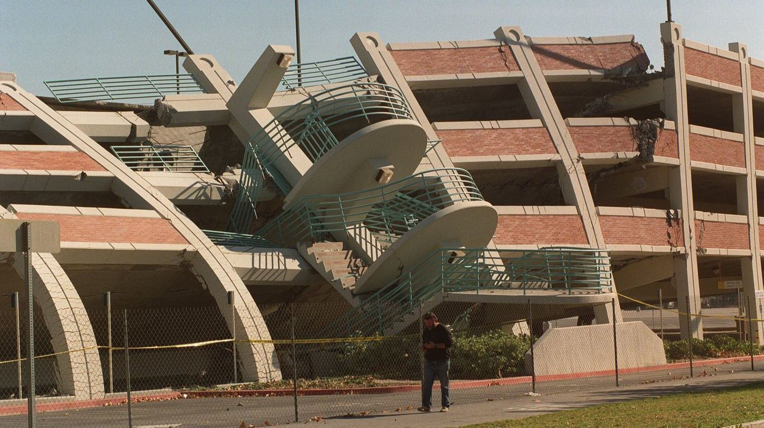
Photograph showing the damage caused by earthquakes

Chapter4. Implement
- Introduction
This contingency plan on earthquake disaster developed by the director of the disaster management team of California hospital medical center (CHMC) has established ways of controlling and tackling the disaster if it occurs. In order to implement this plan effectively, the hospital has to develop standard operating procedures (SOP) that will guide its operations. SOPs are guidelines that help works to carry out their tasks effectively in order to avoid delays and shortcomings. These principles form the basis of the operation of CHMC. Also, the plan aims at informing the public on the possibility of occurrence of an earthquake at later date and also ensure effective assistance to people that are affected by the disaster. As such, the plan encompasses notification methods that the agency has to use in order to inform the public about the possible occurrence of the disaster. Also, it has focused on the resources that the hospital ought to utilize. These are both physical resources and human resources. The plan also has put into consideration how to assemble the resources and maintain them for the benefit of the organization. To enable the full participation of all participants in the disaster coverage, the plan also has considered several ways of staff training and simulation. This will help them to acquire more skills and knowledge that enable them to perform their tasks effectively. Training also will help each participant understand the role they have to play in the disaster management.
- Preparedness gap analysis
This represents the readiness to predict where possible, curb the effects of the disaster and respond to and cope with challenges that may arise due to the effects of the disaster. Earthquakes pose a major challenge to the rescuers and thus fail to accomplish what they were destined to do. As outlined in the International Federation of Red Cross and Red Crescent (IFRC) guideline in dealing with disasters, any organization involved in disaster management should be able to predict the occurrence of the event and be able to put the correct measure to ensure those affected are assisted. To ensure that California Hospital Medical Centre is fully prepared for any occurrence of an earthquake in the state, CHMC has acquired more skilled manpower to deal with the rescue of the affected and giving first aid to them. These are doctors and health workers that have been authorized by the IFRC. These doctors undergo vigorous training to enable them to perform their duties.
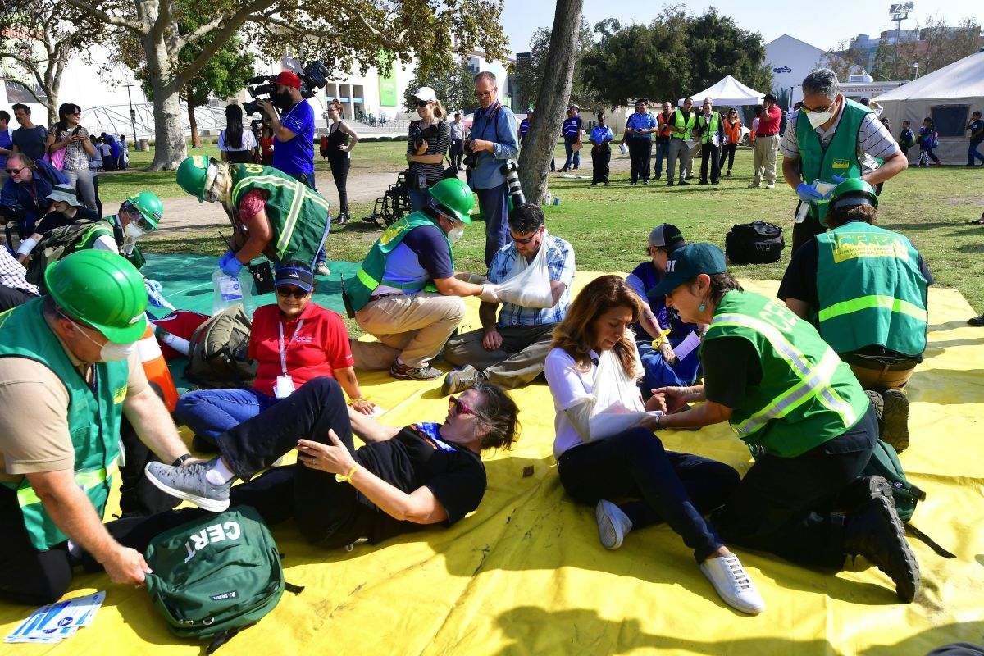
Rescue doctors in California playing their role during the 2017great California earthquake.

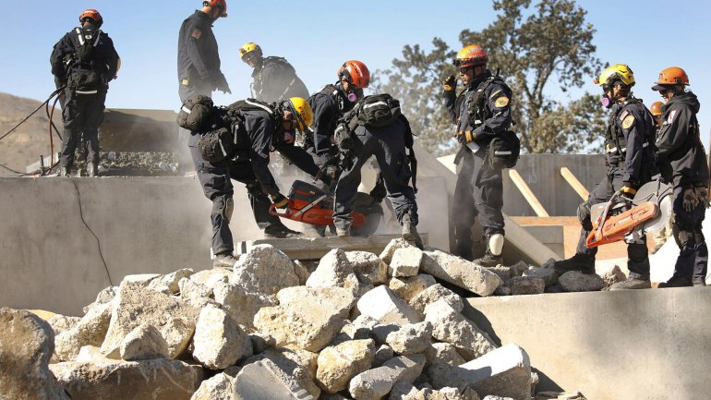
Rescue team during the 2017 earthquake disaster in California
Also, to ensure the CHMC is prepared for earthquakes has strengthened its structures such that the hospital is able to accommodate more victims and also ensure patients are handles in the right manner and time. This includes; acquiring new machines for handling the most affected like scanning machines for bone breakages. Although these facilities are expensive to acquire, the hospital in conjunction with the state government and red cross international, it has been able to acquire these facilities. It has also expanded its physical appearances through the construction of new wards to accommodate the victims. CHMC has also acquired new ambulances for ferrying patients from the scenes of disaster to the hospital for treatment. This has reduced the number of people dying due to late treatment. Going by the current resources available for utilization during earthquake epidemics, CHMC is better prepared for any occurrence, unlike last year’s epidemics. The preparedness gap analysis is low as compared to that of last year. This is so because of the fact that the hospital has acquired new financial support from different organizations. These organizations include non-governmental organizations like the redcross international and also government support.
The hospital also has agreements with other hospitals and the government to give their assistance to the hospital in case an earthquake occurs. They will give assistance in terms of financial support or facilities such as medicines, doctors and vehicles. This is to ensure there are effective measures to deal with any calamity. Also, there are agreements made between the hospital and the national weather forecasting institutions. These institutions have the mandate to inform both the hospitals and the society about the future occurrence of the earthquake. In order to reduce the preparedness gap analysis, the hospital has taken the following measured:
- The hospital will carry out training of its workers to ensure they have the appropriate skills. Also, on the manpower, the hospital will carry out public training to enable them to carry the rescue and also provide semi-skilled labor to the hospital.
- Has acquired new machines and signed agreements with other institutions to provide the missing facilities.
- It has also built new structures to accommodate the admitted patients.
- It has conducted the weather forecasting institutions to provide information on the possible occurrence of earthquakes.
- Also has conducted the media houses to broadcast the information on the occurrence of the disaster.

- Standard operating procedures (SOPs)
CHMC has developed a contingency plan that has group its SOPs into three groups:
- Pre-emergency response procedures
- Emergency response procedures
- Post-emergence response procedures
Pre-emergency SOPS
These are procedures that CHMC indents to use in preparation for the onshore of the earthquake. The hospital will identify the area to be affected by the earthquake and inform the occupants of the area. Also, CHMC will acquire and collect all the required equipment and facilities, including manpower. It will also mobilize the facilities to the anticipated area for easy assessment of the resources. This will enable the rescuers and doctors save time and be able to access the region effectively. Training will also be done to the staff indented to take part in the maintenance of the epidemic. These duties will be performed by:
Name: N/A
Position: N/A
Address: N/A
Phone: N/A
Emergency response procedures
These are the measure CHMC going to use during after the earthquake has occurred. First, CHMC will seek to assist the most affected people in the emergency. These are the injured and any other that may need quick assistance. The main aim of the hospital is to protect the life of individuals thus will ensure the safety of people through the provision of clean water to the affected, adequate food, health care, and shelter. These activities will be done by the doctors and other pre-trained individuals. The activities will be coordinated by:
Name: N/A
Position: N/A
Address: N/A
Phone: N/A
CHMC will also identify disruptive challenges and allow time for resolving them. This is based on resources, and impacts on information system operations. This will be head by the head of department dealing emergencies. He or she will determine how long a disruption is accepted based on its effects. This time should be in conjunction with that set by international federation of red cross and red crescent societies (IFRC).
Name: N/A
Position: N/A
Address: N/A
Phone: N/A
The hospital will also develop priorities that will help to deal with the disaster. This may include determining the time of recovery, requirements to be met, and measures to meet the requirements. This will help in saving time, expenditure, efforts. This duty will be performed the hospital management in conjunction with other agencies like IFRC. It will be chaired by:
Name: N/A
Position: N/A
Address: N/A
Phone: N/A
It will be the obligation of the hospital to develop recovery strategies that will help in improving the standards of the affected people. Discovery strategies are means to restore order. The strategies must consider; cost, security, organizational level, and allowable time. These recovery measures will depend on the impacts identified. The best strategies will be determined by the nature of the earthquake. The strategies should complement each other in order to ensure effective recovery. It will be headed by:
Name: N/A
Position: N/A
Address: N/A
Phone: N/A
Post-emergency SOPS
These are procedures that the hospital wish to undertake after the earthquake has occurred. This may include life assistance measures that will assist the victims to resume their original lifestyle. The hospital will provide food resources, clothing, and shelter to the victims. This will be done through the contingency kitt that the hospital has set aside for such an emergency. Also, funds from government and donors will be used to provide medical care to the injured and medicine. The duties will be coordinated by the financial officer in the hospital.
Name: N/A
Position: N/A
Address: N/A
Phone: N/A
- Early warning, alert systems, and triggers
This involves ways of notifying the public about the earthquake. The hospital will rely on information produced by meteorological institutions, the government, scientist and the IFRC. The hospital will, therefore, pass that information to its branches, interested groups, the public. Mass media will be the main vessel for transmitting the information. Also, the hospital will use early-warning systems established by IFRC with the assistance of the meteorologists. If there are no established means of communication, the hospital will establish its own. The hospital can establish local networks that will enable disseminate information from the hospital and also receive a warning from the public. This will increase public awareness. The hospital will rely on both print and electronic media. Major media facilities to be used include; Beverly Hills studios, tylers editing dungeon, Mathew Scott photography, and Klac-Talk radio A.M 570.
Logistics and programme readiness
Logistics may refer to a systematic organization of complicated activities in order to happen in a harmonious and effective way. Also, it is the process of planning to make sure that resources are available in the places needed so as to ease the performance of any planned activity. To ensure that the hospital is ready for an earthquake, it has acquired doctors from various hospitals. These include; Almedahospital and kindred hospital in Alameda County, Alpine county hospital, Mark Twain St.Joseph hospital and Sutter coast hospital in Del Norte County. Also, it has acquired ambulance services from these hospitals. California hospital medical center has also collected funds for emergence kit from the government and donors. Training has been done to various health workers from different counties of California so as to assist in disaster management. Various recovery strategies have been developed to assist in restoring peoples living standards. Meteorologists have been requested to inform the public about any occurrence of the earthquake. Media houses have been funded to publish and report the occurrence of any disaster. Also, the hospital has distributed medical kits to the chosen hospitals to ensure quick access of them. Also, mechanics have been employed to repair any vehicle that may be in bad condition before the earthquake. The maintenance will be for all ambulance and vehicles that will be used in the maintenance of the disaster. Insurance policies have been acquired to the people who will participate in rescue to ensure their life is secured. As mentioned earlier, the hospital will provide shelter to victims, food, clothing, and medicine, the hospital has acquired these facilities from companies that provide them.

- Human resources
California medical hospital center has identified various human resources to be used in the maintenance of the disaster. This includes; doctors, drivers, managers, rescuers, and public health workers. The doctors have been acquired from various hospitals all over California. The hospital has invited qualified driver with more than three years of driving experience for recruitment. Vigorous training has been done to prepare health workers for the difficult task. The government has been requested to provide its qualified rescuers to assist in the disaster.
- Resource mobilization
Resources mobilization is a critical component to a programme delivery and impact. Resource mobilization is the assembling of resources to be used in a project or programme delivery and impact. This can be represented by three steps. These steps are; plan, act, and reflect. In planning, CMHC will analyze the external resource environment in order to discover the existing opportunities and how to approach them. A strategy is developed. Secondly is the action phase. This phase can be further divided into five steps.
- Identify | Resources like doctors, vehicles, and manpower and their sources.
- Engage | Look for the identified sources and chose the most applicable.
- Negotiate | Prices and means of transport to the desired destinations.
- Manage and report | Acquire the resources and formulate a report on that acquisition.
- Communicate results | Give the effectiveness of the resources acquired.

Thirdly, the reflection phase. Here the strategy is monitored and evaluated identifying the successes and failures. A report is then derived from lessons learned.
- Training and simulation
CMHC will carry out vigorous training on safety measures before and after the disaster. Those to be trained are the doctors, the general public, rescuers, and ambulance operators. In case of the disaster, the media houses will inform the public and request them to move to safe places on behave of the hospital. The hospital will then mobilize resources to the affected areas. In conjunction with IFRC, the hospital will also train some health workers that will handle specific cases. These cases are like the administration of medicine to the victims. The training will be carried out in the hospital premises. Special courses will be administered to the doctors and health workers to enable them to carry out their duties. The training will be conducted by IFRC officials. Others groups that will be involved in the training of workers are; national disaster response team (NDRT), regional disaster response team (RDRT). The hospital will then carry out an exercise to determine the effectiveness of training and procedure formulated. Shortcoming will be derived during the practice.

- Linkages and communications
In order to manage the disaster, it requires special skills and method to be applied. The hospital secretariat and that of other organization like IFRC will develop a framework that will help transmission of information to and from the hospital. The framework will consider five areas. These are; public information, operational information, internal information, reporting, and institutional communication. The general public will be informed on the measure to take in case the disaster has occurred. Also, they should be able to give reports to the hospital in case of an emergency caused by the disaster. Operational information is important in decision making and thus should be managed by the emergency operation center. Information passed from this area involves tasks and guidelines to be followed. Also, the hospital needs to share information within its premises about any emergency. This will be enhanced by internal information. In order to ensure accountability, reporting programme is important. Reporting should be done regularly to the management. Institutional information will enhance coordination between the hospital and other agencies working on the same disaster. These procedures will help to save time and resources available and make maximum impact on the mess.

CHAPTER 5: REVIEW
- Updating and evaluating the plan.
A contingency plan is a backup plan at helps in activations of earthquake disasters that disrupts health care operations. The main objectives of the plan are to safeguard data, minimize disruptions and keep everyone safe. A hospital may use contingency plan because it is very important has it keeps update and training workers what to do if it happen. When the initial plan has been completed
It is very important to evaluate whether the structure and the contented are suited to actually responsible capacities. From the previous sections, it outlines the reason for testing the plan and making changes if it is necessary. It is very essential to recognize that the contingency plan may become outdated due to various changes such as social, economic and political situations.
The contingency plan must be updated on a regular base this is very important for registering and monitoring staffs and their working capabilities and the establishment of modern equipment and logistics resources. Such an example includes a volunteer database may not reflect the current situation this is because of the mapping of red cross crescent resources that have not been undertaken recently due to poor maintenances. The system should be established for ensuring the information’s is checked regularly and updated.
Keeping the contingency plan updated and relevant is a challenging task but can be achieved by regular reviews over a period of time. The plan should also be specific of such reviews for example for a year or more than a year such as every two years. The following are information that requires regular updating
- Logistic transportations plan
- The contact information of emergency responses of staffs and agencies.
- The list of available resources
- The availability of emergency structures.
A contingency plan is very useful because it can be evaluated once updated and also being used in a real-life situation. Evaluation should be made frequently using recent data that have been collected using different methods. This also depends whether the evaluations of the plan is carried out during or after the disaster responses operations.

The process of updating procedures outlined in disaster-response and contingency plans can be kept simple.
- Which section of the plan should be updated? The list of the sections of the plan that are essential must be updated thus not all element must be updated in the same way.
- When frequently to update the plan. The frequency should be Cleary be defined when each part of the plan should be updated. This will depend on how the information is important and also the frequency of which is likely to change. In detailed it is very important to update the contingency plan more frequently than the disaster responds plan.
- Which method should the plan update? The most appropriate method should be used according to sections of the plan under considerations.
- Who is responsible for updating which sections? The duties of updating different elements of the plan should be dived up and maximizing uses of the resources in the institutions. For example, each department updates the element that is in their plan such as the human resource manager update those sections related to their capabilities.
- What resources that are required in updating the plan? The appropriate resource is required in updating the plan and if additional resources are needed they must be included in the budget.
- Registering the changes that have been made in the plan. The registry is very important to be maintained especially when the changes have been made and it should also include the numbers of copies made and who have received them for a future update.

- Evaluating the contingency plan during and after the responses.
The true test of the contingency plan in its implementation during actual or real disaster responses activities. An operations test is carried out during the planning concept and the assumptions. During evaluations of an operation, it gives an opportunity to observe how well, the plan actually deal with operations activities and requirement.
To carry out real-time evaluations, during a particular occasion a specified person or organized group of people are carefully selected to act as the observer during the first day of the plan implementation. They use pre-described methods and indicators to do evaluations of a different aspect of the plan so that to be able to reach in conclusions and also identify actions that are necessary for improvements. This kind of evaluations has a very special value in emergencies this is because their scope and complexity involve humanitarian actors and many countries thus it requires close observations.
Methods of evaluating operations may be qualitative or quantitative and include case studies, survey research, and statistical analysis.
For example uses of secondary data such as newspapers, reports and other agencies and interviews that focus groups of people, use of questionnaires with the staffs. With all different methodologies, major issues and recommendations are developed to make sure that future plan and operations build for successes that address identified problem area affected by the earthquake.

The following are questions that are asked during evaluations.
- What are the strength and weakness of the contingency plan? And how to improve them.
- What cause the most casualties and damage? What are remedies that should be done to prevent it in the future?
- What is the major problem that faces affected people from getting help/
- How does warning system work? What is the improvement required?
- What types of mistake were done and how to prevent these in the future?
- Which resources were available and which were lacking? How could this be corrected to prevent future earthquakes?
- What’s was the level and quality of coordination with national society and with other partners? How could these coordinations be improved?
The following are responsibilities for evaluation contingency plan.
The national society contingency plan
It is used to determine the required content and the format of their own contingency plan and the various process that is used to evaluate them. The leaders of national society require formal evaluations of each national and branch level of the contingency plan for a period of time. The plan should only be evaluated when required changes are made as well as following disaster relief operations. The IFRCSs disaster management technical staffs are able to assist in the development, evaluations and the reviews of the sections of the plan. The national society should evaluate the contingency plan after a certain period of time such as for every two years.
IFRC contingency plan.
The IFRC secretarial is responsible for the evaluation of each regional contingency plan for every two years. it is also responsible for caring out an annual review to ensure the contingency plan describes each section to ensure movement of and coordination and provides disaster responses of earthquakes in an effective and timely manner. This may include the responsibility to evaluate contingency plan for a high-risk area such as Los Angeles California.IFRC regional heads of delegations and the disaster management coordinators are responsible and accountable for ensuring that regional contingency plans are in place.

Annex2.
Sector responsibilities
Below are the major components for the sectors which are important especially to disaster response and incidents planning, like deadly earthquakes. The sectors include; food security and nutrition, the supply of water, health, sanitation, and hygiene promotion, shelter and settlement.
1. Emergency Assessment
Immediately after an emergency has occurred, there is a great need for making assessments and consistent updates about the situation where the incident took place. Proper training should be inducted to both the staff and volunteer members of the community. This is mainly for the purpose of ensuring uniformity on methods, indicators, and standards used during the assessment time. Locals, especially in areas prone to earthquakes, should be highly trained so that they can be able to conduct an immediate damage assessment in case of emergency. The following factors should be considered when planning for an emergency needs assessment whether at local, community or even regional level;
- The person responsible for the assessment and when will it be taken. For instance, persons undertaking an assessment should have different functions and areas of specialization, and also the real time of taking that assessment e.g. immediately, after days, weeks or even months after the event has occurred.
- Information needed at each stage of an emergency, because information varies e.g. the cause, effects, and nature of the event.
- Ways and place of collecting the response team, for example, criteria for selecting respondents and training them.
- The standards used to measure undesirability of the earthquake.
- Elements incorporated during the assessment to facilitate early recovery of the affected area.
- Determination of the impact of humane support in the affected area. For example are they positive or negative?
- The need for better programming initiative guidelines, that is, will they help to reduce the damages once the earthquake occurs again?
- Lastly, ways of involving the beneficiary community in the process of disaster assessment. It may include certain procedure such as academic qualification based on disaster assessment.

2. Continuity of operations during emergency
Disasters usually happen unexpectedly; sometimes they may disable a city/town, society and also the community's functions through property damages, injuries, and death of top officials. However, society's functions cannot be seized and for this reason, there is a great significance to plan for the continuity of its operations. The following should be considered;
- Selecting and setting up another place that is capable to support important activities.
- Informing the relevant bodies for crisis management for them to be aware of the site relocated and enables its operations to be efficient.
- Providing temporary transport and communication support.
- Distributing volunteer staff from their normal operating areas to the affected area to add their assistance.

3. Rescue and first aid
Earthquake emergencies usually result in injuries and death, regardless of whether it has affected an area or a region there must be a clear plan outlining rescue and first aid policies as stated below;
- Possible types of injuries and medical care resulting from the scenario and clearly shown in the plan.
- Responsible bodies, for example, The California Red Cross Red Crescent for rescue operations and the personnel responsible for organizing it.
- Ways of handling human remains.
- Responsible persons for organizing first aid, temporary ambulance, medical and hospitalization.
- An appropriate system for registering and distributing medicine all over the affected area.
4. Health services
As a result of an emergency, unconducive conditions may arise such that they encourage the outbreak of dangerous diseases. The affected people in the area of Los Angeles should, therefore, be able to access conducive shelters, proper nutrition and access to safe water in order to avoid the outbreak of such diseases. Otherwise, health issues that should be put into consideration include;
- Personnel responsible for health and nutritional needs during an emergency.
- The nearest local healthcare and how it works during an emergency.
- Appropriate place of giving out vaccination especially for infectious diseases like measles.
- The need for supplementary feeding requirements because people from Los Angeles are different, for instance, children may use certain food also pregnant and lactating mothers.
- All bodies including governmental and nongovernmental agencies that are responsible for health care, disease prevention, and public health campaigns.
- Health protection and nutritional needs provided during different seasons like winter and also correct measures that should be taken during seasonal variation.
- Ways of overcoming overcrowding especially in healthcare during and after the earthquake have occurred.
- Appropriate measures that should be taken to different population groups’ e.g. children, women, men, adults and elderly.
- Medical requirements available and any addition on supply that might be needed and in what quantities.
- Proper storage facilities to avoid spoilage of medicine and other medical facilities.
- Ways of addressing psychosocial issues in its cultural and technical context. Bodies and policies should be created that focuses on this issues.

5. Water, sanitation and hygiene promotion
Earthquake can disable the various functions in the area such as unsafe water, inappropriate sanitation facilities and also unhygienic commodities that can make many people prone to illness or death from water and sanitation related diseases. Water is life, people can stay without food but they cannot really survive without water hence there is a great significance in providing clean drinking water. Additional, sanitation and hygiene promotion also helps in reducing environmental pollution. In order to conserve the environment, the following measures should be taken especially to the areas affected by an earthquake; safe hygiene practices, proper disposal of human waste, insects and rodents control, site drainage and wastewater management practices.
In order to be able to determine the quality of water especially for consumption, the following should be considered,
- Source of water, both the quality and quantity and also its current users.
- Technology applied in pumping the water.
- Availability of distribution channels, if present their closeness to peoples homesteads.
- Water treatment techniques available.
Availability of water storage facilities like tanks, reservoirs applied when there are no other sources of water in the area.

For the other case of sanitation, the following can be specified;
- Current defecation practices on sanitation facilities and the responsible personnel whether from public or private sector.
- People should also construct and use toilets.
- Conducting appropriate programs to educate people on the importance of good sanitation.

For hygiene, the following should be considered;
- Residents of Los Angeles should be consulted especially on their water, sanitation and hygiene needs.
- Traditional beliefs related to water collection, storage, and usage.
- Availability of water storage containers.
- The current beliefs on waste and excreta disposal especially regarding gender and also access to material for anal cleaning.
- Residents from Los Angeles should also get accessed to water and soap and wash their hands after defecation and before meals.
- Females/ladies should also get access to materials for menstrual hygiene.
- Education, especially on hygiene practices, should be taught to the people of the affected areas.
6. Food and nutrition
Food and nutrition’s are a very essential component in the human body as they are required for survival. During earthquake disaster, the affected people require moistly food and nutrition are mostly for emergency purpose. The disaster management plan should be prepared and be able to calculate the cost that is required. When planning for the disaster there some questions that should be for relevant context such as national.
- Who is responsible for the assessment of food supply need and also the department is responsible in case the disaster occurs.
- What food is available in the geographical area of disaster? what is the cost of the food that is available in Los Angeles, California?
- Which traditional is dominated in Los Angeles California?
- What items should the various food baskets contain?
- What food distributions system has been previously used in Los Angeles California?
- Who is responsible for communicating with the government and other international donors such as NGOs?
- What are the food storage requirements? what are food storage facilities locally available?
7. Relief
Relief is a feeling of reassurances and relaxations due to the occurrence of distress or anxiety, financial or practical assistance provided. The plan for disaster management should address the way in which emergency for a basic need such as food shelter and clothing and also security. Most of the area the situations are very different the list of resources that are required to be used should also vary for required priorities. The national and regional should address the following.
- What items will be needed and which of these are available in Los Angeles California?
- Who will coordinate the negotiation of pre-existing agreements with suppliers
For these required items?
- To what extent can local markets in California and organizations assist in the distribution of such goods?
- How can these mechanisms be strengthened to play a bigger role in relief
activities in California?
- What are the local storage capacities and what additional facilities will be
Required in relief activities in California?
- What are the available stock reserves of blankets, water containers, fuel for
food preparation, stoves, kitchen utensils, clothing, and another essential nonfood
items that required in California?
- What are the targeting, registration and distribution processes? Who is
responsible for the management of relief supplies in Los Angeles California?
- Who is responsible for needs assessment in California?
- How will a monitoring and evaluation process be ensured in Los Angeles California?
- How will the coordination of quality, quantities be ensured n California?

8. Shelter.
- In most cases, basic need emergency such as shelter provision is needed for the people whose homes have been destroyed or are unsafe. the distribution of shelter facilities such as tents and tarpaulins for temporary shelter, or sheltering homeless people in public buildings such as schools and hospitals.
- What is the governmental policy for sheltering a disaster-affected population in an area such as Los Angeles California?

- What governmental, local and international organizations are active in
shelter provision in California?
- Who is responsible for management and needs assessment relating to shelter provision in the local area in California?
- Are supplies of tents, construction materials and plastic sheets needed in the local area in California?
- Have sites or buildings for communal shelters been identified for possible
Large-scale emergency needs in the local area in California?
- How will sites be identified? Are there difficulties related to land ownership?
What potential problems may occur within the local community?
- What particular difficulties may arise in various seasons in the local area in California such as winter, summer, rainy, etc.?
- What types of assistance will be needed by those who are sheltered or hosted
by relatives and friends.
- Would the provision of cash be more appropriate to provide people of California with choice of options?
- What traditional construction materials are available local areas in Los Angeles California? Does the procurement and use of traditional building materials harm the environment?

9. Restoring family links
One of the most priority social-welfare tasks in many relief operations is to quickly
Initiate a search for missing people in the disaster and reunite them with the family members. The family is the basic social unit in most societies and plays a key role in meeting personal
Needs and solving community problems in society. National Societies responsible for
Restoring family links should consider the following issues in planning at
national and regional levels.
- Who is responsible for managing search and reunification activities in the local area in California and who will be involved?
- Is the ICRC or host National Society involved in providing relief action in California?
- How many families may need temporary accommodation in the local area in California?
- What are the cultural norms that may delay reunification activities in the local area in California?
- Which methods or approaches will be used to carry out these activities in the local area in California?
- Which communication methods will be used to reunite family members in the area such as Los Angeles in California?
- What other agencies and government departments are responsible for these
Operations? What level of coordination is required?
- At which stage of response should search operations be started in the local area in California?

- How will the affected population learn about this service in the local area in California?
10. Protection, safety, and security
Preparedness plans should identify who is responsible for the protection, safety, and security of the disaster-affected population in Los Angeles California. This is usually the responsibility of the national government and other sectors other actors may be involved. The
plan should also identify the actions to be taken to ensure the security of Red
Cross Red Crescent staff and volunteers involved in disaster response. Security
is a complex issue and the IFRC has developed appropriate guidelines that are available on Fed Net.

Annex 3
Identifying capacities and resources.
Identify internal and external capacities.
In the identification of internal resources is important therefore we should not forget there are other organizations that work in the same area that we are planning for interventions.
It is very important to be aware of resources and capacities which will help us to avoid operations cost and for a better development of our strategies and collaborations agreement. This will also help us to make use of the available resource for a better operation.

Incorporate potential future resources.
It is very important to know that the existing resources and capacities are the only ones that we can use in operations. From experiences from the previous earthquake we are able to know that depending on the type of and size or magnitude of the event, we can also count on donors, partners and other nongovernmental organizations that can help us to purchase other additional resources.
These enable us to be prepared and have better strategies for adaptation and organizational growth.

Which capacities and resources should be identified?
The capacities and resources should be many in such a way that they are not limited so that they can help to make the operation successful. However, when dealing with the planning of a national society four area can be identified which can integrate important actors in the time of disaster responses.
- Internal institutional capacities and resources
- External institutional capacities and resources
- Agreement with other partners.
- Community capacities and resources.

Internal institutional capacities and resources
Internal capacities include all different organizational from both public and private sectors that help to strengthen their intuitional capacity and also members of the movement with a presence in the country or not and can send to the area of disaster that is defined by contingency plan for the identified priorities
Human and institutional capacity development is very important challenges for any institutions which directly has an impact on organizational performances.
In recent year successfully implementations intuitional development and capacity have taken place. The effort of implementations is through the following.
- Change management
- Capacity development
- Human resources managements
- Human and institutional capacity development
- Public relations and communications

External institutional capacities and resources government and other institutions.
These include the capacities and resources that come from other institutions and organizations outside of the movement that has high responsibilities and is willing to act in a geographical area that is affected by the disaster. According to the mission of the external institutions, their role and responsibilities can be grouped into three group governmental intuitions, nongovernmental institutions, and multilateral or bilateral organizations .each organizations have a specific role in the contingency plan.

ANNEX4.
Standard operating procedures (sop)
A standard operating procedure is a set of step by step instructions that are compiled by the organizations so that to help the workers carry out routing operations without many difficulties. It aims to achieve efficiency, quality, and uniformity of organizations performances also reducing barriers to communications.
An SOP defines the expected practices in all institutions where quality standard are expected.SOP includes policies, procedures, and standard, marketing and administrations disciplines within the intuitions to ensure success in operations. SOP can create
- Fewer errors in all operations
- A way to resolves conflicts between different departments
- Efficiencies and therefore low operations cost.
- Healthy and safe environment
- Protections of employers in a risky area such as earthquakes damage areas.
- Consistency and reliability in productions of services
Standard operating procedures have the following characteristics.
- Must be simple and easy to understand such as using simple words.
- Must clearly indicate how a task is supposed to be done and who is responsible for the tasks.
- Must be able to stand on their own.
- Must be approved and the disseminated within the organizations and also used in training.
Standard operating procedures should at least contain the following element
Title. It shows what the SOP cover.
Date of issues: ( 23 October 2018)
Period of validity :(23 October 2018- 18-1 may 2019
To be reviewed by (14 may 2019)
Purpose of the SOP; In the event of earthquakes in Los angelus in California, established of a health department in support with national societies should help in the disaster.
Responsible department: (disaster department).
Responsible positions :( head of disaster care department)
Process and decision that will trigger the use of the sop: The national society management body, the president, head of disaster responses department. The decisions on the needs to respond to the emergency, the initial assessment shows which relief and items are needed.
Example of a contingency plan.
Relations with other entities and operations.
These sections must show the following elements.
- Coordination’s needs
- Link to others
- Information system and the media
- Equipment maintainer’s inspections and procedures.
- New employee training
- Other as appropriate
Safety and security.
Security of the officers that are caring out the SOP much be provided so that to prevent any distractions that may occur during the operations.
Operational activities.
The procedures of the operation must be carried out informal process for successful implementation of sop .flow charts and checklists are very helpful in this stage.
Training / simulating with the sop.
The training of the health staff will be carried out on a specific date and time.
Review of the sop.
The review of the SOP will be carried out in specific date indicated above each year and after operations in which SOP is activated. The head of health care and the head of disaster management are responsible for organizing the reviews and also ensuring that finding is incorporated in the SOP.
Some sections are required to be changed and immediate modification of the SOP. The SOP also requires minimum regular reviews and evaluations that must be carried out and changes incorporated in the sop immediately. More ever regular reviews, evaluations, and modifications of the sop should take place after every operation that is used.
Annexes.
- Checklist
- Contact list
- Resources list
- Forms and templates
- manuals
- other as necessary

References
Dobalian, A., Claver, M., Riopelle, D., Wyte-Lake, T., &Canelo, I. (2017).The Development of a Veterans Health Administration Emergency Management Research Agenda. PLoS currents, 9.
Kedar, S., Owen, S., Jones, C., Donnelan, A., Glasscoe, M., & Duren, R. (2016). Select Technologies and Capabilities to Improve Earthquake Resiliency in California.
Liu, B. F., Fowler, B. M., Roberts, H. A., &Herovic, E. (2018).Keeping hospitals operating during disasters through crisis communication preparedness. Public Relations Review.
Peek, L., Ryder, S. S., Moresco, J., & Tucker, B. (2016). Disaster Risk Reduction Strategies in Earthquake-Prone Cities.In Multi-hazard Approaches to Civil Infrastructure Engineering (pp. 507-532).Springer, Cham.

